Unit 9 – Activity 1 | Daniel Bullock | May 13th 2016 (Problem Definition)

**The Purpose or Reason for Doing the Project**

* My project is an adventure game made in java that will be presented entirely in text format.
* Personally, I want it done to say that I made something in java that was not previously thought out by a curriculum; also I’d like to pass this class.
* The title right now is “Text adventure game,” but that will certainly change.

**The Goals or Target of the Project**

* The project will achieve hopefully a passing mark, but also a java program that works with minimal error.
* The user is required to type in their choices that they feel is the right choice in the situations presented.
* Some of the given facts or assumptions are that the user has a computer with java, a keyboard and that they understand English. The user must also read the instructions at that come with the game showing how to play.
* I would like to achieve this goal by June 20th 2016 (at the latest).
* I aim to create a game that works and is as immersive as a game with no graphics and just text can be. I also aim to create something that runs smoothly with minimal errors and has multiple outcomes based on the user’s decisions.
* These goals are essential to the project because without them there would just be an unorganized mess of a project that ultimately might not even work.

**The Benefits or Gains of the Project**

* I don’t see this project making things better, unless you count my mark in this course.
* There is always a need for games in the market, but I doubt this one will sell, or be sold.
* People who like fantasy adventure games will benefit with a good time and will gain happiness (hopefully).
* I doubt the users really want this game, but I’m making it anyways.
* 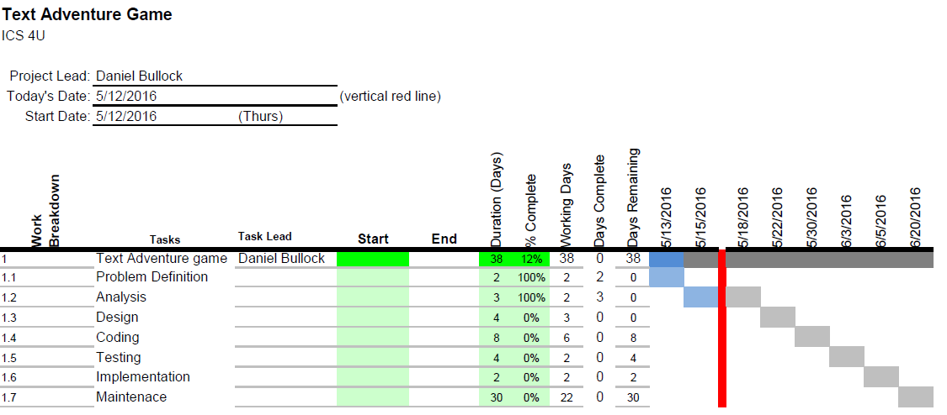This project is however, important to me because it will be my first complete game I’ve created in java (by myself) and I’ll always have it.